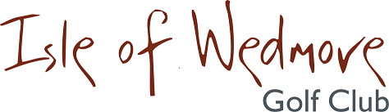

YONEX TROPHY

Sunday 17th October 2021

18 Hole Individual Open - Stableford
Open to Men and Ladies

Divisional Prizes
Best Visitor Prizes (Men and Ladies)
Nearest The Pin Prizes
Optional 2’s Sweep

A GREAT DAY OUT….

ENTRANCE FEE:
£8 PER MEMBER
£20 PER VISITOR

Please contact the Pro Shop for more details:
01934 712452 or email: proshop@wedmoregolflcub.com

