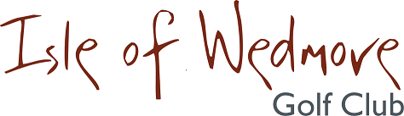

‘Lineage’, Lascot Hill, Wedmore, Somerset BS28 4QT
Tel: 01934 712222 Email: office@wedmoregolfclub.com

Senior Ladies 3 Ball Open Bowmaker
Full Handicap Allowance
2 Scores to Count

Tuesday 8th June 2021

Entry Fee
£18 Visitors
£8 Members

- Enter in Teams of 3.
- All visitor teams welcome.
- All member teams.
- Or combination of visitors and members.
- Ladies need a Handicap Index. Maximum Handicap 36
- Soft Spikes Only

Please pay by BACS, the details are: Isle of Wedmore Golf club – Ladies Section
Account No: 83120668
Sort Code: 30-98-97
Or make cheques payable to ‘Isle of Wedmore GC Ladies Section’ and send with a SAE to:

Claire Biggs, Apple Tree Cottage, Sparrow Hill Way, Weare, Somerset, BS26 2LA
Tel: 01934 732917 Email: francescbiggs@icloud.com

