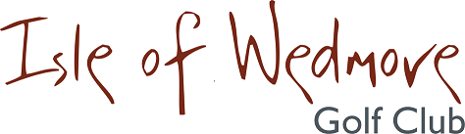

‘Lineage’, Lascot Hill, Wedmore, Somerset BS28 4QT
Tel: 01934 712222 Email: office@wedmoregolfclub.com

Ladies Spring 3 Ball Open Bowmaker
Full Handicap Allowance
2 Scores to Count

Thursday 20th May 2021

Entry Fee
£18 Visitors
£8 Members

- Enter in Teams of 3
- All visitor teams welcome.
- All member teams.
- Or combination of visitors and members.
- Players need a handicap index. Maximum Handicap 36
- Soft Spikes Only

Please pay by BACS to Isle of Wedmore GC Ladies Section
sort code 30-98-97
account no 83120668
Pam Berry, 7 Rye, Puriton, Bridgwater, TA7 8TA
Tel: 01278 683674 Email: Pamjberry.berry@googlemail.com

