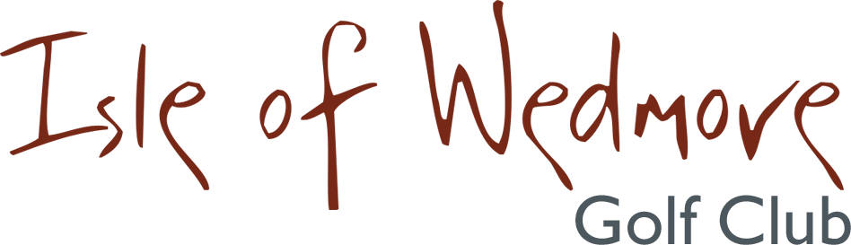

‘Lineage’, Lascot Hill, Wedmore, Somerset BS28 4QT
Tel: 01934 712222 Email: office@wedmoregolfclub.com

Ladies’ Open Competition Entry Form 2021
Competition: Ladies’ 3 Ball Bowmaker Date: Thursday 20th May 2021
Entry Fee: £18 Visitors, £8 Members

 | Title | Name & CDH ID Number | H’cap | Home Club | Pref.  Tee-time
1
2
3

Please make payment via BACS:
Isle of Wedmore GC Ladies Section Account No: 83120668 Sort Code: 30-98-97

Contact Address …………………………………………….
…………………………………………….
…………………………………………….
…………………………………………….
Post Code …………………………………………….
Contact Tel. No. …………………………………
Email: …………………………………
Active Handicap Certificates will be required on the day. Maximum Handicap 36
Please quote your CDH IDs on the entry form.
Confirmation of your application and Tee-times will be emailed to you.
If you have not supplied an email address, please enclose a S.A.E with your entry form.
Please send your entry form and payment to:
Pam Berry 7 Rye, Puriton, Bridgwater TA7 8TA
Tel: 01278 683674 Email: pamjberry.berry@googlemail.com

