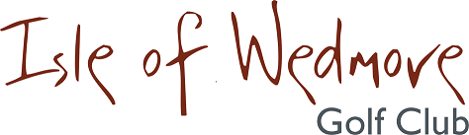

‘Lineage’, Lascot Hill, Wedmore, Somerset BS28 4QT
Tel: 01934 712222 Email: office@wedmoregolfclub.com

Ladies Autumn 4 Ball Open Bowmaker
Full Handicap Allowance
2 Scores to Count

Thursday 26th August 2021

Entry Fee
£18 Visitors
£8 Members

- Enter in Teams of 4
- All visitor teams welcome.
- All member teams.
- Or combination of visitors and members.
- Players need a handicap index. Maximum Handicap 36
- Soft Spikes Only

Please pay by BACS to Isle of Wedmore GC Ladies Section
sort code 30-98-97
account no 83120668

Wendy Lucas, 7 Watts Corner, Glastonbury, Somerset, BA6 8FD
Tel: 01458 831906 Email: wendydavidlucas@googlemail.com

