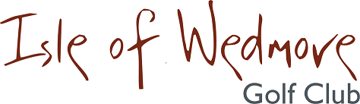

‘Linage’, Lascot Hill, Wedmore, Somerset BS28 4QT
Tel: 01934 712222 Email: office@wedmoregolfclub.com

JUNIOR OPEN
Thursday 5th August 2021

Open to Boys and Girls under 18 years of age on 1st January 2021

Tee Times will be allocated between 12:30pm and 2:30pm

18 Hole medal
Boys max handicap 28, girls max 36

9 Hole Stableford, Open to Boys & Girls max handicap 54

Subject to any current covid restrictions, we hope to offer a full catering service which will be available throughout the day.

Entry Fee £8 per player 18 holes and £5 per player 9 holes.

Please send your entry form and payment to:
James Wilde. 15 Hythe Wood, Cheddar, Somerset, BS27 3FH
Please make cheques payable to “Isle of Wedmore Golf Club Limited”
_____________________________________________________________
All Enquires to the Junior Organiser, James Wilde email: jameswilde@me.com

