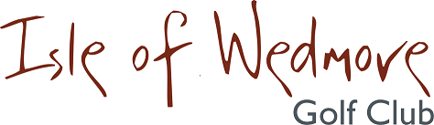
‘Lineage’, Lascot Hill, Wedmore, Somerset BS28 4QT
Tel: 01934 712222 Email: office@wedmoregolfclub.com

Junior Open Competition
Thursday 5th August 2021
Entry Form
Entry Fee: £8 per player 18 holes and £5 per player 9 holes

Closing date for entry is Monday 19th July 2021 or when full

Name …………………………………………….
Club …………………………………………….
Handicap Index ………
CD HID ………………………..
Contact Address …………………………………………………………….
…………………………………………………………….
…………………………………………………………….
…………………………………………………………….
Post Code ……………………….
Contact Tel. No. ……………………….
Email: …………………………………………………………….

Please send your entry form and payment to:
James Wilde, 15 Hythe Wood Cheddar, Somerset, BS27 3FH
All enquiries to James Wilde Tel: 07590070406 Email: jameswilde@me.com

I enclose a cheque for the total of £ ……………… made out to ‘Isle of Wedmore Golf Club Limited’
together with the completed entry form and email address
(No refund available for cancellations 7 days prior to the event)

Confirmation of your application and Tee-times will be emailed to you.

