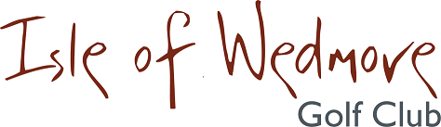

‘Lineage’, Lascot Hill, Wedmore, Somerset BS28 4QT
Tel: 01934 712222 Email: office@wedmoregolfclub.com
Yonex Trophy Entry Form 2019

Competition: Individual (Men’s & Ladies) Date: Saturday 12th October 2019
Entry Fee: £18 Visitors £8 Members

Title | Name & CDH ID Number | H’cap | Home Club | Pref.  Tee-time

I enclose a cheque for the total of £ ……… made out to Isle of Wedmore Golf Club Limited
(No refund available 14 days prior to the event)
Contact Address …………………………………………….
…………………………………………….
…………………………………………….
…………………………………………….
Post Code …………………………………………….
Contact Tel. No. …………………………………
Email: …………………………………

Active Handicap Certificates will be required on the day.
Please quote your CDH IDs on the entry form.
One entry form per person required
Confirmation of your application and Tee-times will be emailed to you.
If you have not supplied an email address, please enclose a S.A.E with your entry form.
Please send your entry form and payment to:
Isle of Wedmore Golf Club Limited
Tel: 01934 712452 Email: proshop@wedmoregolfclub.com

