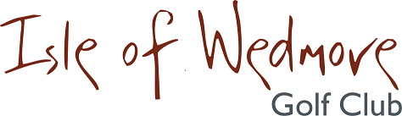

YONEX TROPHY

SATURDAY 12th OCTOBER 2019

18 Hole Individual Open - Stableford
Open to Men and Ladies

Divisional Prizes
Best Visitor Prizes (Men and Ladies)
Nearest The Pin Prizes
Optional 2’s Sweep

A GREAT DAY OUT!

ENTRANCE FEE:
£8 PER MEMBER
£18 PER VISITOR

Please contact the Pro Shop for more details:
01934 712452 or email: proshop@wedmoregolflcub.com

Closing date for applications; Thursday 10th October
Application forms from Golf Empire.

