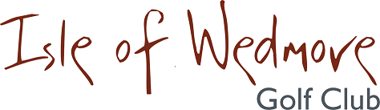

‘Lineage’, Lascot Hill, Wedmore, Somerset BS28 4QT
Tel: 01934 712222 Email: office@wedmoregolfclub.com

Seniors’ Open Competition
Monday 30th April 2018

18 Holes Individual Stableford
(Qualifying)

Full Handicap. Three Divisions.

Butcombe Trophy for the overall winner
Geoff Lunt Cup for the best scoring visitor
70+ years best score prize

Entry Fee
£18 Visitors
£8 Members
Including entry for 2’s

Closing date for applications 23rd April 2018
Application forms from your Seniors’ Secretary or on line at www.wedmoregolflcub or Golf Empire

