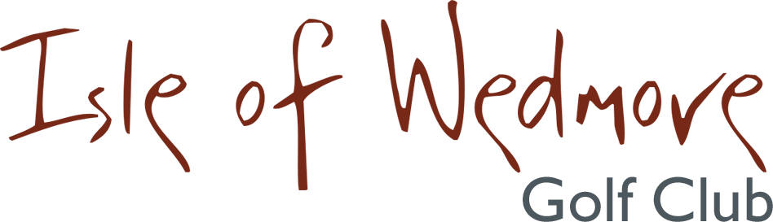

Seniors’ Mixed Pairs Open Competition

Friday 12th October 2018
18 hole Greensomes Stableford
Prizes for best home pair
best home/visitor pair
best visitor pair
Best “70+pair’s combined score”
ENTRANCE FEE
£36 PER VISITOR PAIR
£16 PER MEMBERS PAIR
£26 PER MEMBER/VISITOR PAIR
(INCLUDING ENTRY FOR 2’S AND NEAREST THE PIN)

COMPLIMENTARY COFFEE & BACON ROLLS ON ARRIVAL

MEALS AVAILABLE ALL DAY (NOT INCLUDED IN PRICE)

Closing date for applications 21st September 2018
Application forms from Golf Empire

