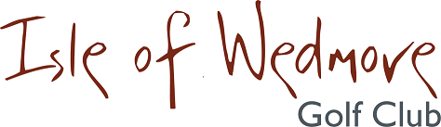

‘Lineage’, Lascot Hill, Wedmore, Somerset BS28 4QT
Tel: 01934 712222 Email: office@wedmoregolfclub.com

Senior Ladies Open 3 Ball Bowmaker

Full Handicap Allowance
2 Scores to Count

Tuesday 5th June 2018

Entry Fee

£18 Visitors
£8 Members

Active Handicap Certificates are required to be shown
on the day please. Maximum Handicap 36

Prizes for Visitors and Members Teams

Soft Spikes Only

Please make cheques payable to ‘Isle of Wedmore GC – Ladies Section’ and send with a SAE to:
Claire Biggs, Apple Tree Cottage, Sparrow Hill Way, Weare, Somerset BS26 2LA
Tel: 01934 732917 Email: francescbiggs@icloud.com

