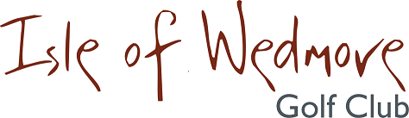

‘Linage’, Lascot Hill, Wedmore, Somerset BS28 4QT
Tel: 01934 712222 Email: office@wedmoregolfclub.com

Ladies Spring 3 Ball Bowmaker Open
Stableford Scoring
Full Handicap Allowance
2 Scores to Count

Thursday 9th May 2019

Entry Fee

£18 Visitors
£8 Members

Enter in Teams of 3

Active Handicap Certificates required to be shown
on the day please – Maximum Handicap 36
Prizes for Visitors and Members Teams
Soft Spikes Only

Please make cheques payable to ‘Isle of Wedmore GC – Ladies Section’
and send with a SAE to:
Wendy Lucas, 7 Watts Corner, Glastonbury, Somerset BA6 8FD
Tel: 01458 831906 Email: wendydavidlucas@googlemail.com

