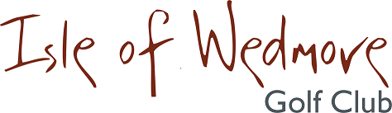
‘Lineage’, Lascot Hill, Wedmore, Somerset BS28 4QT
Tel: 01934 712222 Email: office@wedmoregolfclub.com

Ladies’ Open Competition Entry Form 2018

Competition: Ladies’ Spring 3 Ball Bowmaker Date: Thursday 10th May 2018
Entry Fee: £18 Visitors £8 Members

 | Title | Name & CDH ID Number | H’cap | Home Club | Pref.  Tee-time
1
2
3

I enclose a cheque for the total of £ ……… made out to ‘Isle of Wedmore GC – Ladies’ Section’
(No refund available 14 days prior to the event)
Contact Address …………………………………………….
…………………………………………….
…………………………………………….
…………………………………………….
Post Code …………………………………………….
Contact Tel. No. …………………………………
Email: …………………………………

Active Handicap Certificates will be required on the day. Maximum Handicap 36
Please quote your CDH IDs on the entry form.
Confirmation of your application and Tee-times will be emailed to you.
If you have not supplied an email address, please enclose a S.A.E with your entry form.
Please send your entry form and payment to:
Wendy Lucas, 7 Watt Corner, Glastonbury, Somerset BA6 8FD
Tel: 01458 831906 Email: wendydavidlucas@googlemail.com

