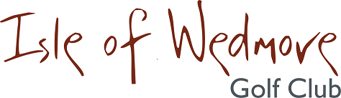

‘Lineage’, Lascot Hill, Wedmore, Somerset BS28 4QT
Tel: 01934 712222 Email: office@wedmoregolfclub.com

Ladies Spring 3 Ball Bowmaker Open
Full Handicap Allowance
2 Scores to Count

Thursday 10th September 2020

Entry Fee
£18 Visitors
£8 Members

- Enter in Teams of 3
- All visitor teams welcome.
- Combination of visitors and/or members.
- Active Handicap Certificates are required to be shown on the day please. Maximum Handicap 36
- Soft Spikes Only

Please make cheques payable to ‘Isle of Wedmore GC Ladies Section’ and send with a SAE to:

Wendy Lucas Marstrand House, 7 Watts Corner, Glastonbury, Somerset BA6 8FD
Tel: 01458 831906 Email: wendydavidlucas@googlemail.com

