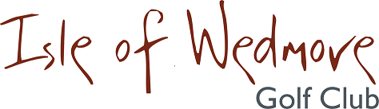

‘Lineage’, Lascot Hill, Wedmore, Somerset BS28 4QT
Tel: 01934 712222 Email: office@wedmoregolfclub.com

Ladies Autumn 4 Ball Open Bowmaker
Handicap Allowance 85%
2 Scores to Count

Thursday 27th August 2020

Entry Fee
£18 Visitors
£8 Members

- Enter in Teams of 4
- All visitor teams welcome.
- Or combination of visitors and members.
- Players need a handicap index. Maximum Handicap index of 32.6
- Soft Spikes Only

Please pay by BACS to Isle of Wedmore GC Ladies Section
Sort Code: 30-98-97 Account No: 83120668
Or pay by cheque Isle of Wedmore GC Ladies Section
Please send entry form to:

Helen Tanswell – 3 The Uplands, Mark, Highbridge, Somerset TA9 4NH
Tel: 01278 641393

