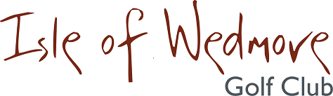

‘Lineage’, Lascot Hill, Wedmore, Somerset BS28 4QT
Tel: 01934 712222 Email: office@wedmoregolfclub.com

Ladies Autumn 4 Ball Open Bowmaker
Full Handicap Allowance
2 Scores to Count

Thursday 30th August 2018

Entry Fee
£18 Visitors
£8 Members

- Enter in Teams of 4
- All visitor teams welcome.
- All teams to have at least 1 visitor.
- Or combination of visitors and members.
- Active Handicap Certificates are required to be shown on the day please. Maximum Handicap 36
- Soft Spikes Only

Please make cheques payable to ‘Isle of Wedmore GC – Ladies Section’ and send with a SAE to:

Gill Jones, Mount Pleasant Farm, Coast Road, Berrow, Somerset TA8 2QU
Tel: 01278 751859 Email: gillandrick@sky.com

